Booking Form
Please complete the form to request a booking of meeting/training/conference room and services at Resource Center for Civil Society Organisations, FIQ premises, Address: Pejton, Str. Pashko Vasa, nr.12/1, 10000 Pristina, Kosovo, Phone number; 038 610 677

Organisation
Contact person
Email and phone number
Date and Time (from-to)
Number of guests and conference room setting
Number of panellists (if any)
Topic and brief agenda

Conference room setting (Select one of the options below)

Circle | 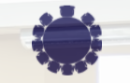 |  | U-shape | 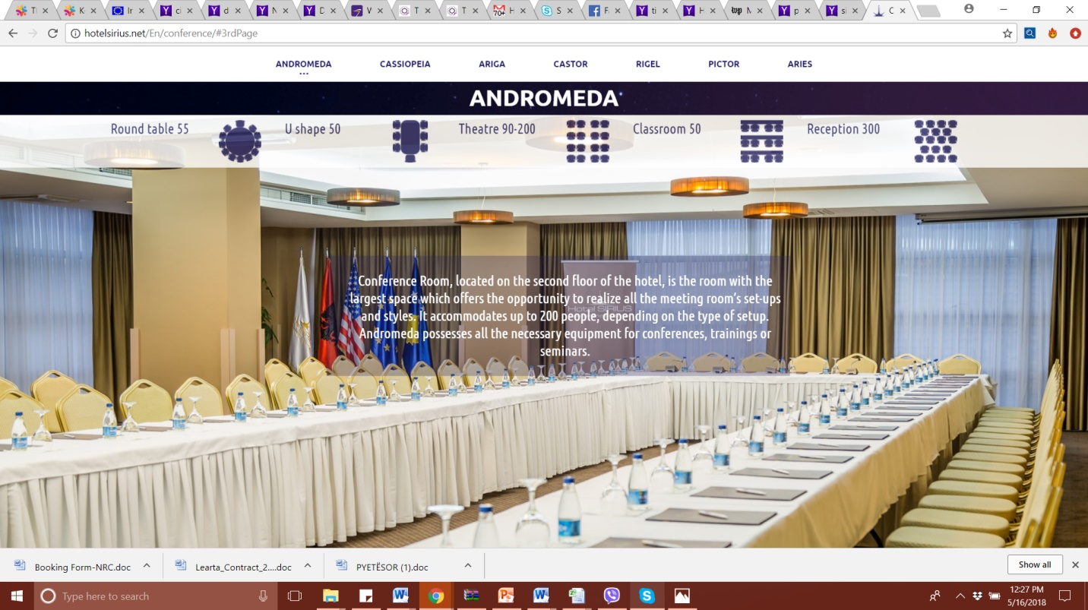
Theatre |  |  | Reception | 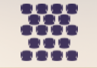

Check List
Please tick the equipment and services needed
 | Projector |  | Podium
 | Computer |  | Coffee  Break

Terms of Lease
RC
offers its facilities free of charge: up to 20 seats in the training room and 12 seats in the meeting room, a computer with internet access and an overhead projector.

Terms of lease of the conference and meeting room:

- Event organiser shall not charge the event participants any fee.
- Booking form for the usage of the conference room should be sent at least seven (7) days prior to the event. In case of cancellation, the organiser shall notify RC no later than two (2) working days prior to the scheduled event.
- Costs incurred from usage of interpreters, refreshments during coffee breaks, hostesses should be covered by the event organizer. If needed the RC will provide the list of caterers and interpreters the organizers can choose from and book. All other logistical activities such as sending of invitations, accepting confirmations, reproduction of materials, etc., should be covered by the organiser.
- By sending the booking form, the organiser ensures that the information in the form is true and accurate and confirms to have read and accepted terms of lease. RC reserves the right to refuse future bookings from event organisers that have violated the above terms.
- Information about the events that are open to the public, will be posted in the Facebook page: https://www.facebook.com/resourcecenterkosovo/

Please send the booking form to: cso@fiq-fci.org

